1. **Introduction:**

A leading music-catering company is planning to analyze large amount of data received from varieties of sources, namely mobile app and website to track the behaviour of users, classify users, calculate royalties associated with the song and make appropriate business strategies. The file server receives data files periodically after every 3 hours.

So as per periodic data for every 3 hours, we need to calculate the queries and return the results to business/customer.

1. **DATASET:**

1. Data coming from web applications reside in /data/web and has xml format.

2. Data coming from mobile applications reside in /data/mob and has csv format.

3. Data present in lookup directory should be used in HBase.

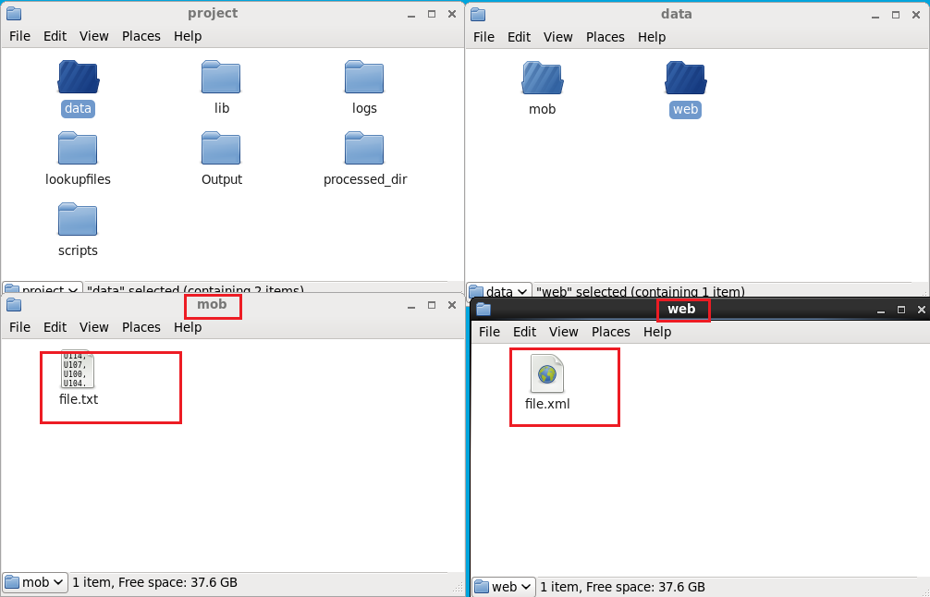

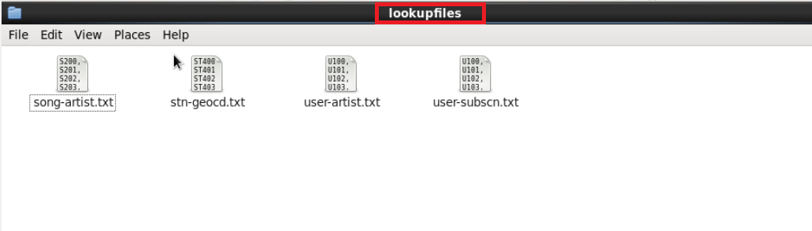

1. **Flow of Operations:**



1. **Low Level Design:**

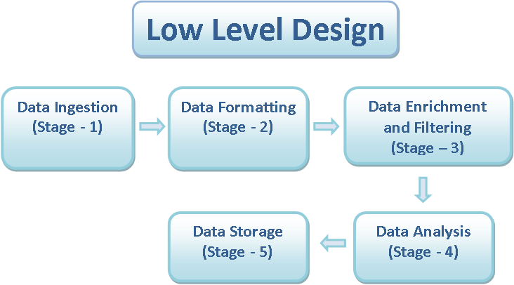

1. **High Level Design**

**High Level Design**

**(Stage - 1)**

**Data Ingestion**

* **Storage of raw data to HDFS**

**(Stage - 2)**

**Data Formatting**

* **Collection of web data and mob data in Hive Table**
* **Tools Used: Pig and Hive**

**(Stage – 3)**

**Data Enrichment and Filtering**

* **Use of Lookup Tables to enrich the raw data**
* **Segregation of valid and invalid data**

**(Stage - 4)**

**Data Analysis**

**Analysis of valid data in Spark**

**Creation of Hive tables to store analysed data**

**(Stage - 5)**

**Data Storage**

**Export of Analyzed data from Hive to MySql**

1. **Implementation:** 
   1. **Starting all daemons in Hadoop:**

* In this script we will start all the daemons that are required to start the services like hive, hbase, MySQL etc.

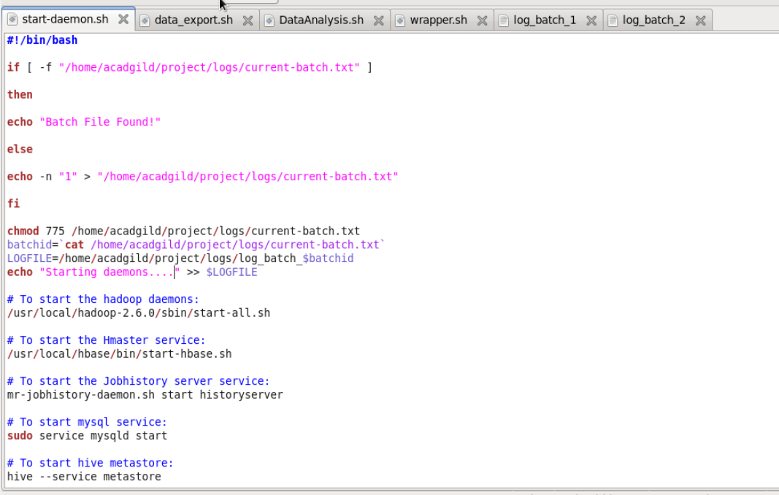

* Terminal with all the daemons started screenshot.

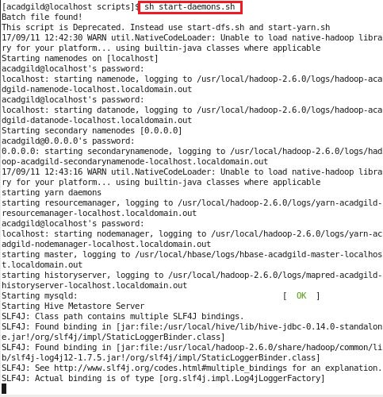

* With the help of **jps**  command we can list out the services that are currently in active state.

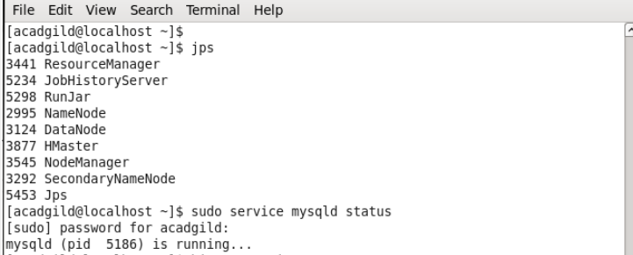

The start-daemon.sh script will check whether the current-batch.txt file is available in the logs folder or not. If not it will create the file and dump value ‘1’ in that file and create LOGFILE with the current batchid.

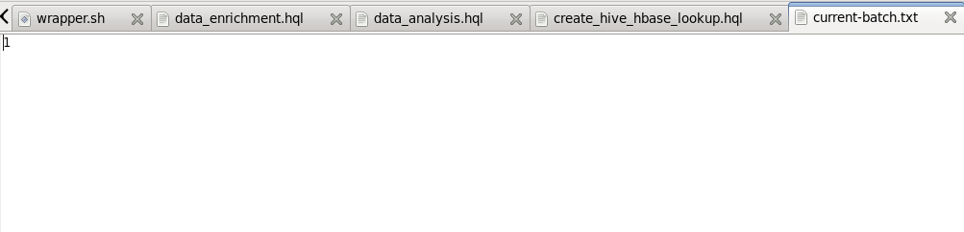

**Lookup Tables creation in HBASE:**

By using the populate-lookup.sh script we will create lookup tables in Hbase. These tables have to be used in data formatting, data enrichment and analysis stage.

|  |  |
| --- | --- |
| **Table Name** | **Description** |
| Station_Geo_Map | Contains mapping of a geo_cd with station_id |
| Subscribed_Users | Contains user_id, subscription_start_date and  subscription_end_date.  Contains details only for subscribed users |
| Song_Artist_Map | Contains mapping of song_id with artist_id  alongwith royalty associated with each play of  the song |
| User_Artist_Map | Contains an array of artist_id(s) followed by a  user_id |

These 4 lookup files are used to create Hbase tables using populate-lookup.sh script and then with the help of data_enrichment_filtering_schema.sh file we will create hive tables on the top of Hbase tables using create_hive_hbase_lookup.hql

Script.

* 1. **Creating Lookup Tables :**

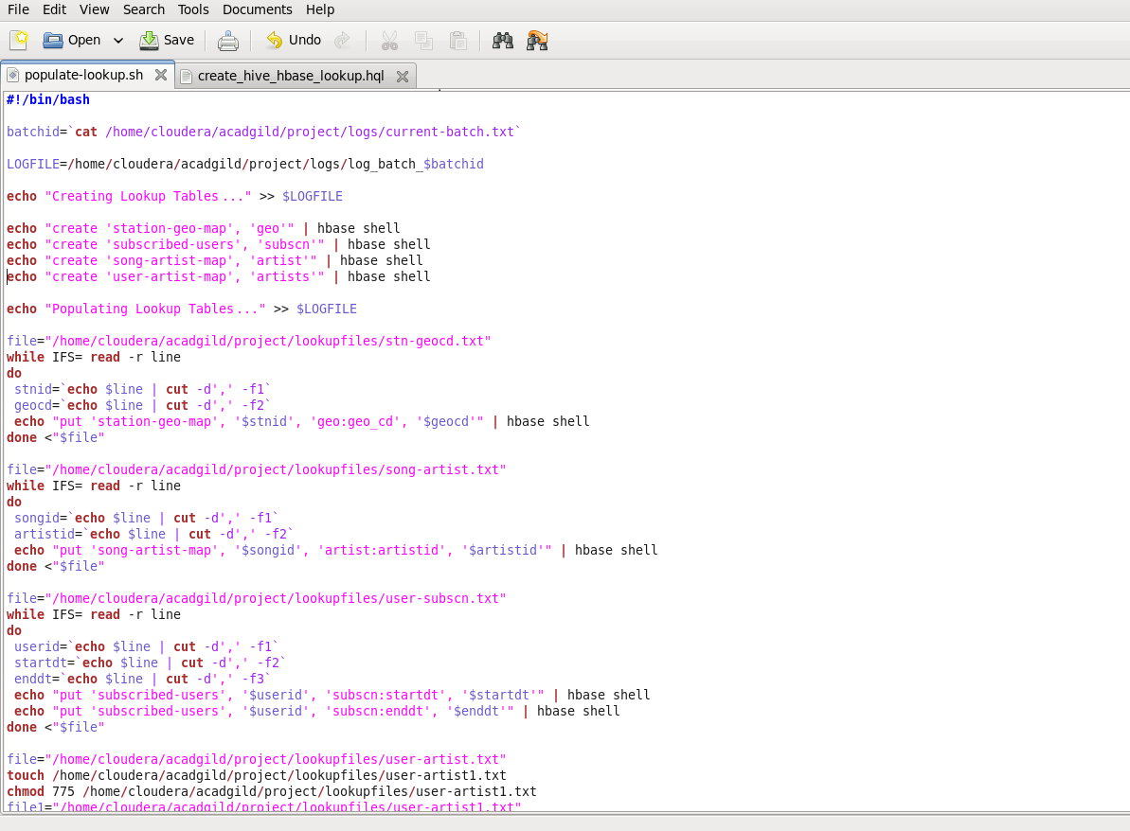

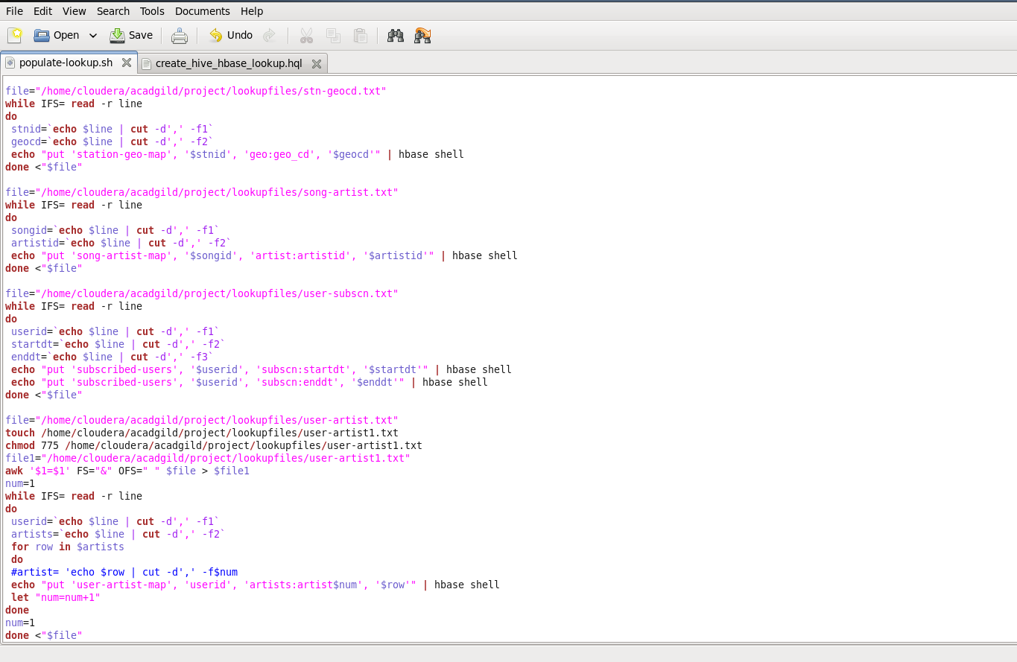

By using the shell scripting I created 4 lookup tables in Hbase NoSQL Database.

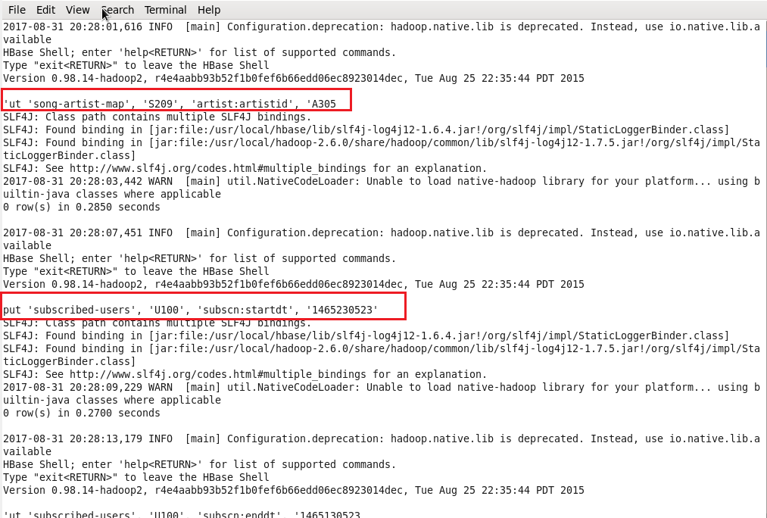

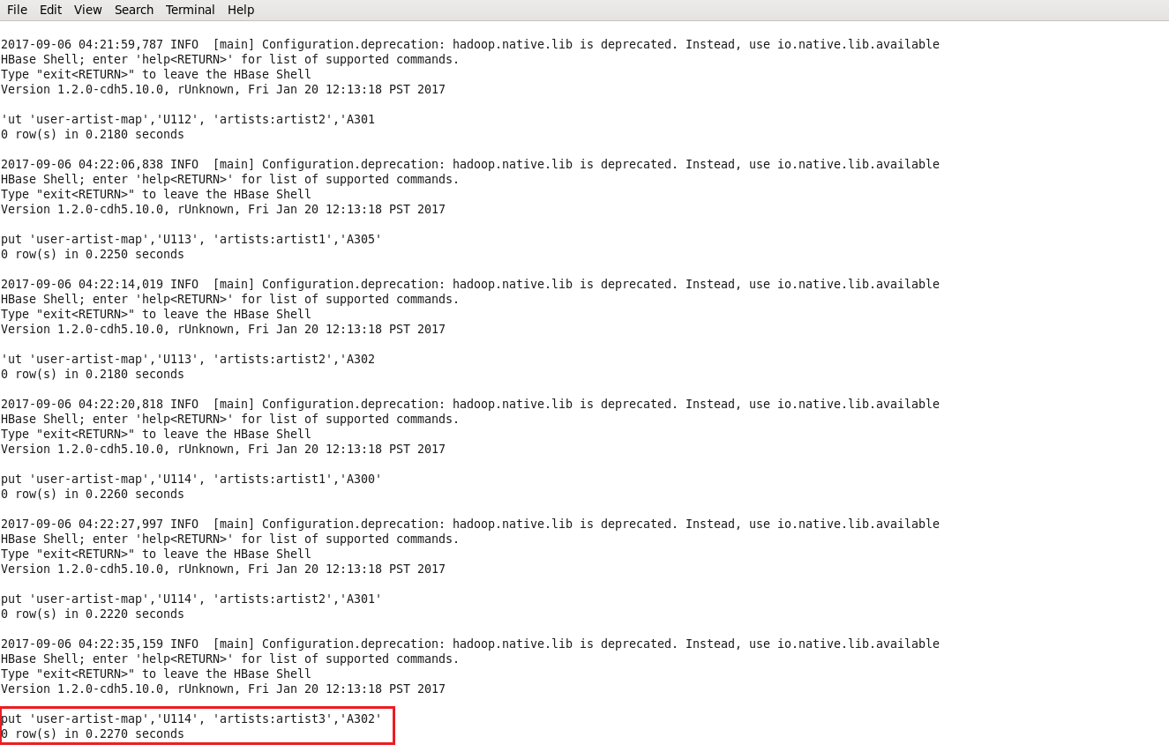

Now we can see the lookup tables in Hbase shell terminal as shown below:

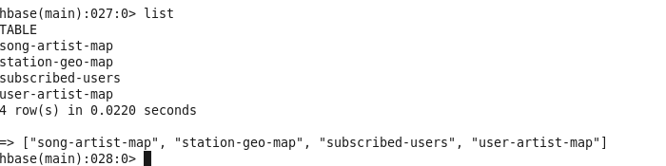

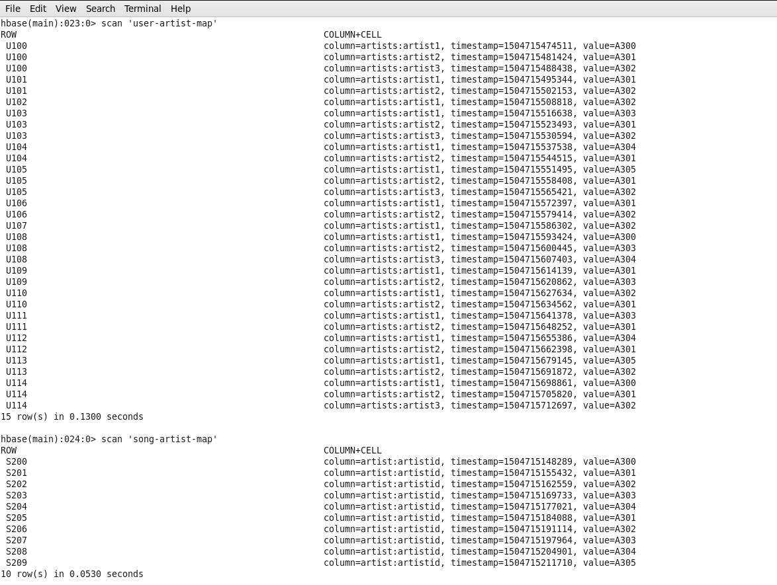

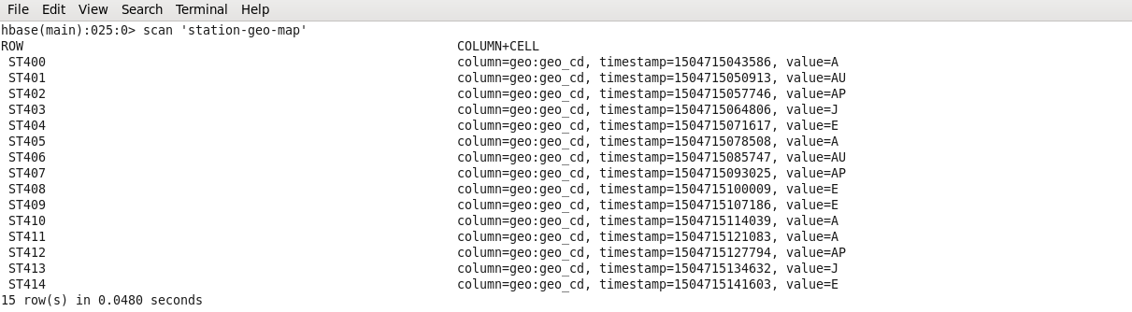

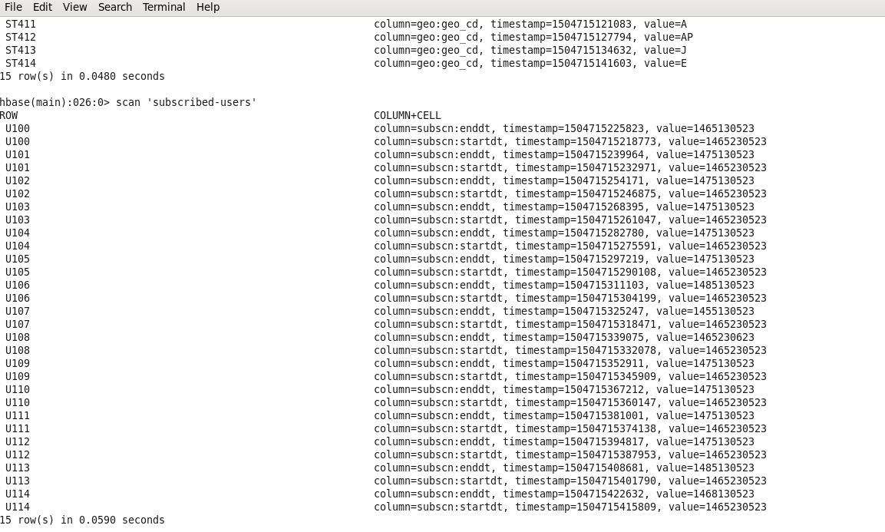

Now Lookup table creation is completed. So now we need to link theses lookup tables in hive using the Hbase Storage Handler.

* 1. **Creating Hive Tables on the top of Hbase:**

In this stage with the help of Hbase storage handler & SerDe properties we are creating the hive external tables by matching the columns of Hbase tables to hive tables.

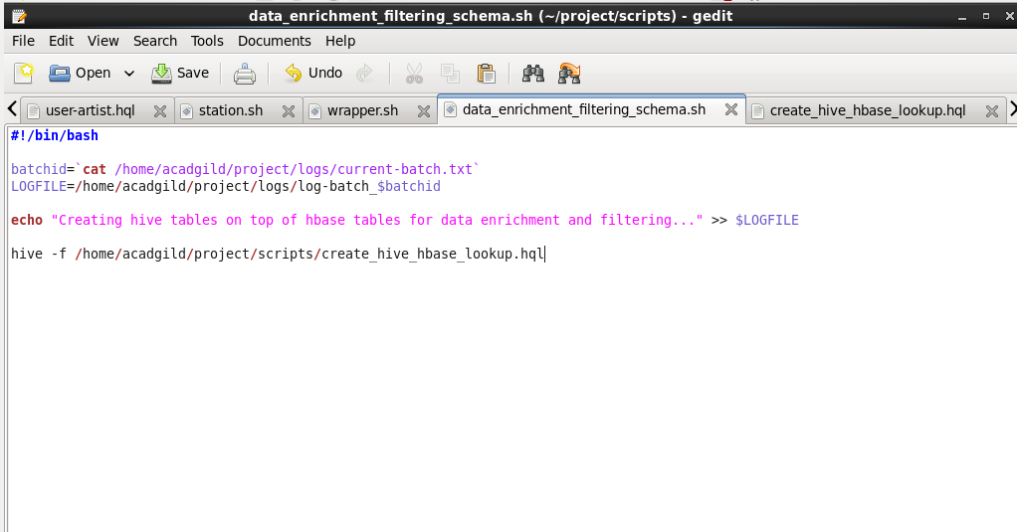

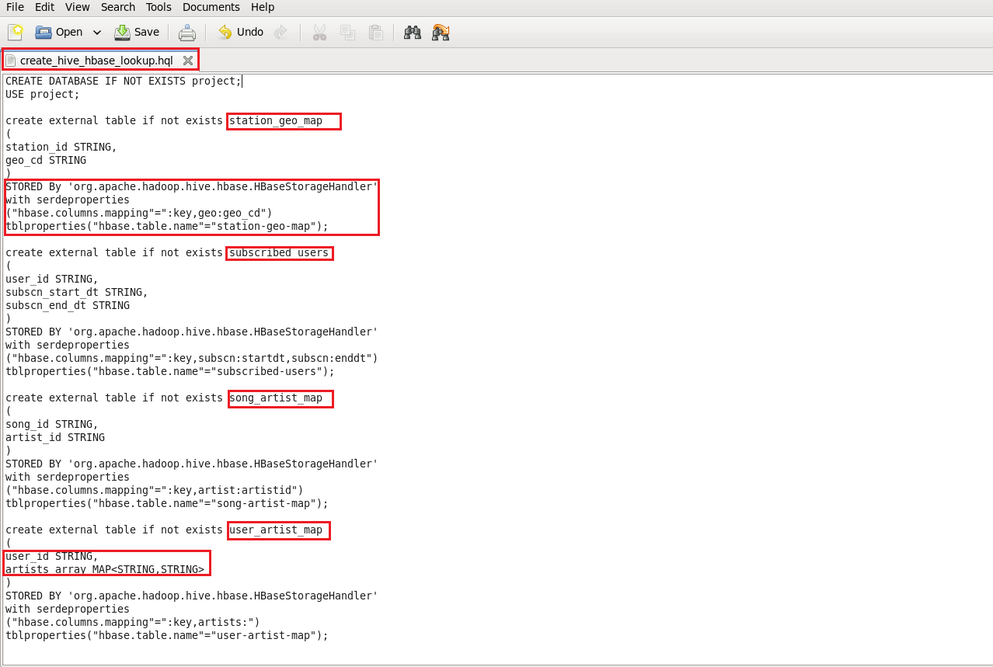

* In the below screenshot we can see tables getting created in hive by running the data_enrichement_filtering_schema.sh file.

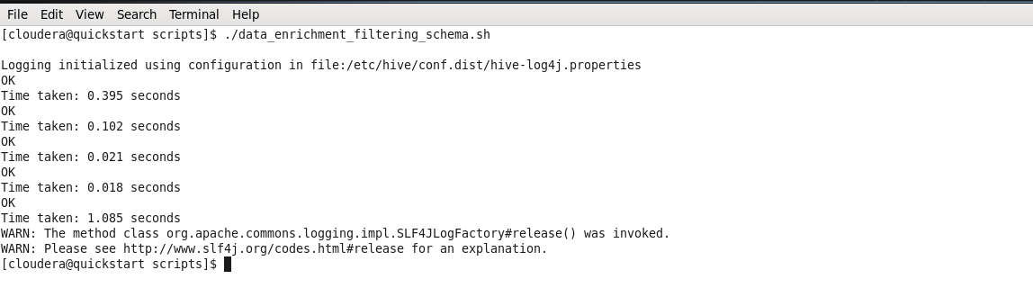

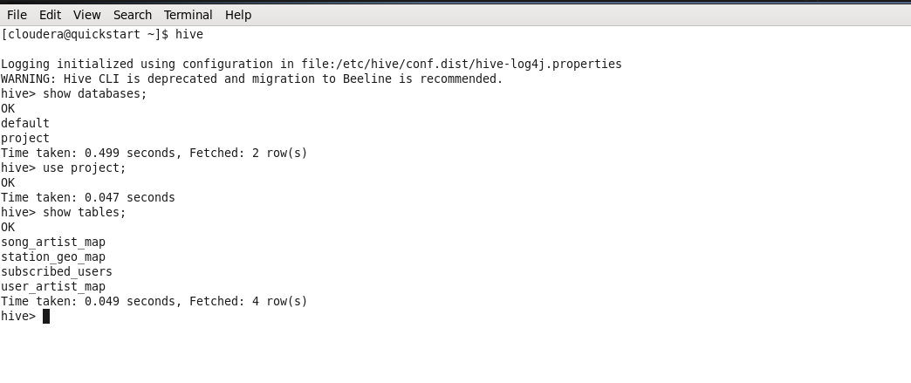

* 1. **Data Formatting:**

In this stage we are merging the data coming from both web applications and mobile applications and create a common table for analyzing purpose and create partitioned data based on batchid, since we are running this scripts for every 3 hours.

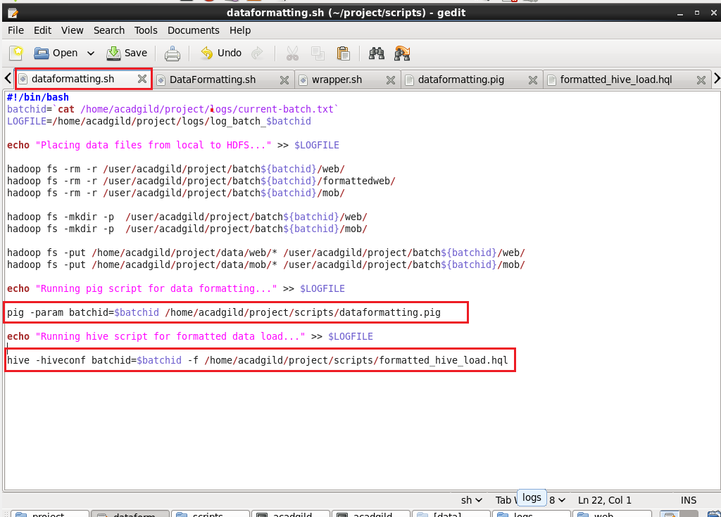

I am running two scripts to format the data. They are: 1) Dataformatting.pig

2) Formatted_hive_load.hql

Pig script to parse the data from coming from web_data.xml to csv format and partition both web and mob data based on based on batch ID’s

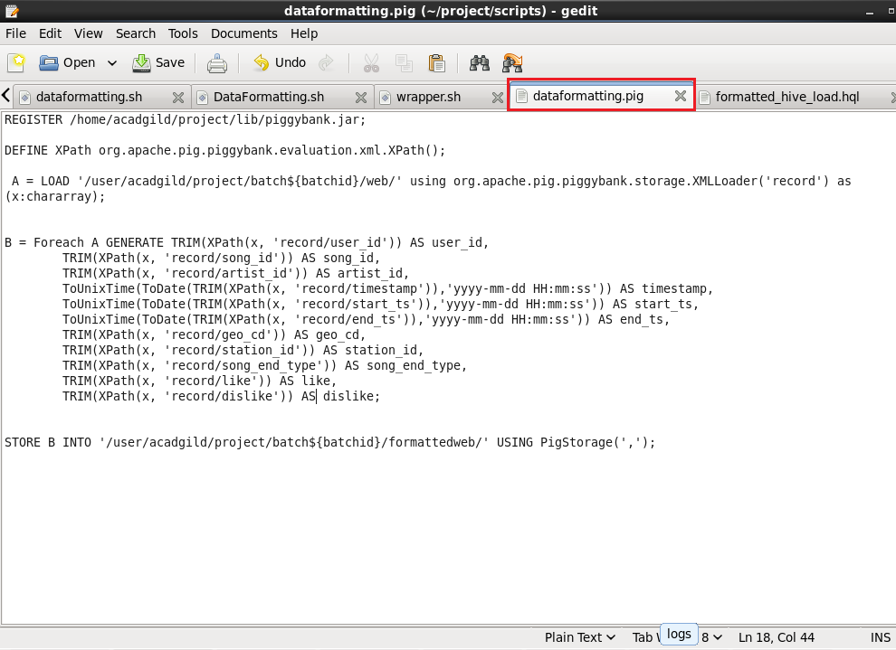

Hive script to load the parsed data from pig to hive and do analysis based on this data.

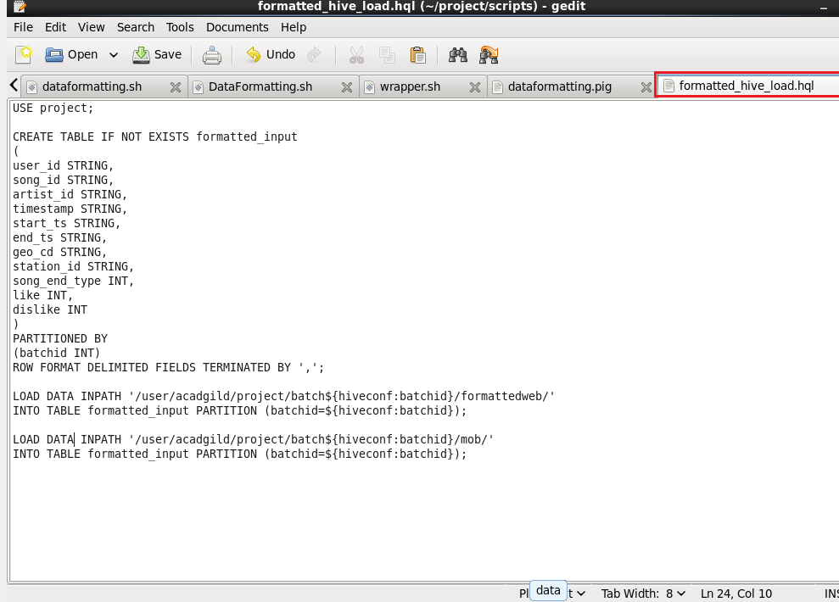

In the below screenshot we can see the data both the scripts in action, first pig script will parse the data and then hive script will load the data into hive terminal successfully.

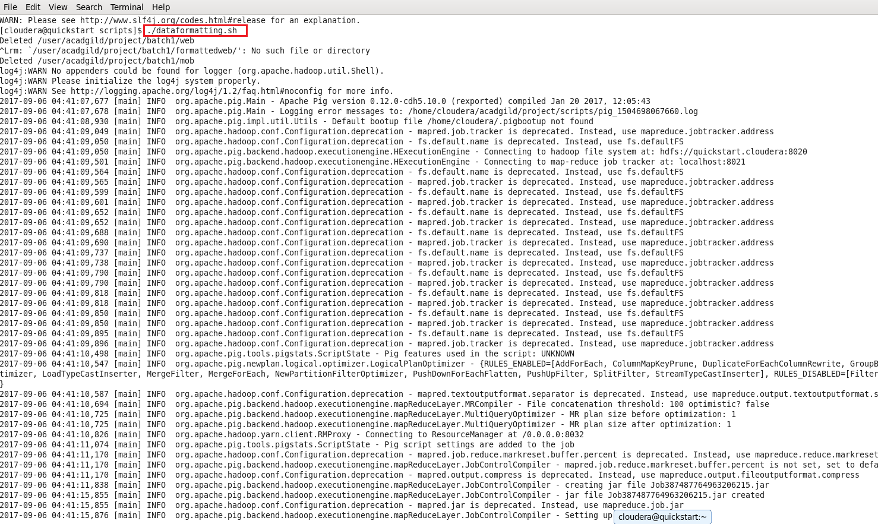

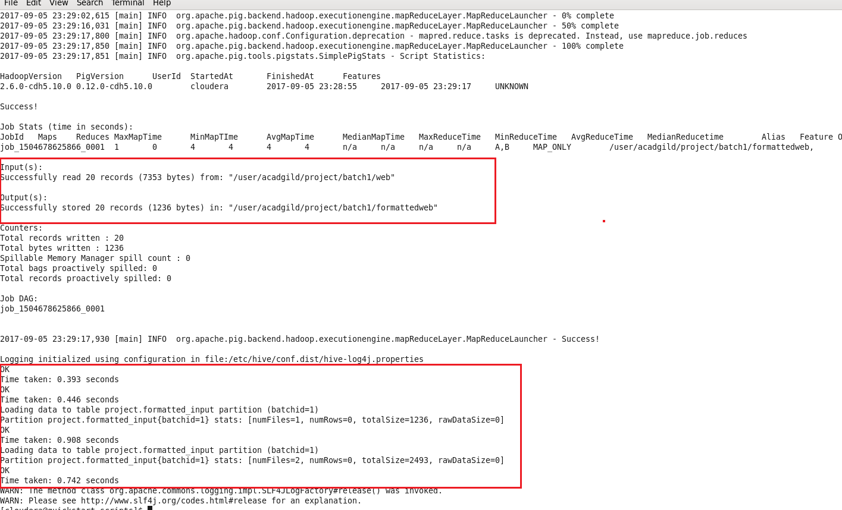

In the above screenshot we can see the dataformatting.pig along with the formatted_hive_load.hql executed successfully.

The output of dataformatting.sh script in HDFS folders:

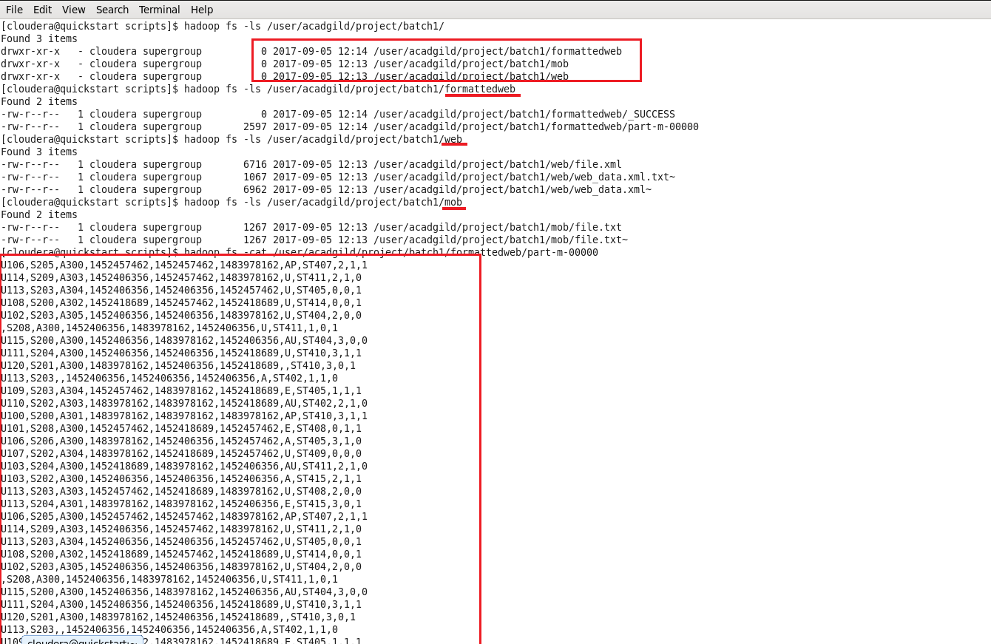

DataFormatting.sh output in hive terminal:

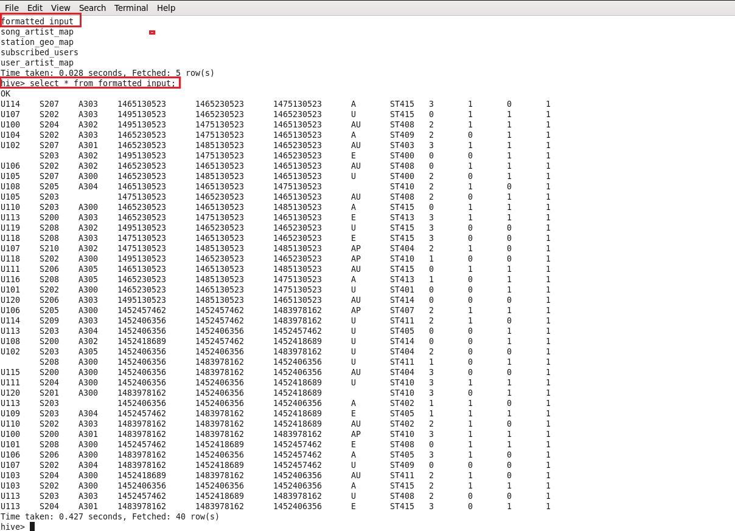

* In the above screenshot we can see the formatted input data with some null values in user_id, aritist_id and geo_cd columns which we will fill the enrichment script based on rules of enrichment for artist_id and geo_cd only. We will get neglect user_id because they didn’t mentioned anything about user_id for enrichment purpose.
* Data Formatting phase is executed successfully by loading both mobile and web data and partitioned based on batchid.
  1. **Data Enrichment:**

In this phase we will enrich the data coming from web and mobile applications using the lookup table stored in Hbase and divide the records based on the enrichment rules into ‘pass’ and ‘fail’ records.

Rules for data enrichment

1. If any of like or dislike is NULL or absent, consider it as 0.

2. If fields like Geo_cd and Artist_id are NULL or absent, consult the lookup tables for fields

Station_id and Song_id respectively to get the values of Geo_cd and Artist_id.

3. If corresponding lookup entry is not found, consider that record to be invalid

So based on the enrichment rules we will fill the null geo_cd and artist_id values with the help of corresponding lookup values in song-artist-map and station-geo-map tables in Hive-Hbase tables.

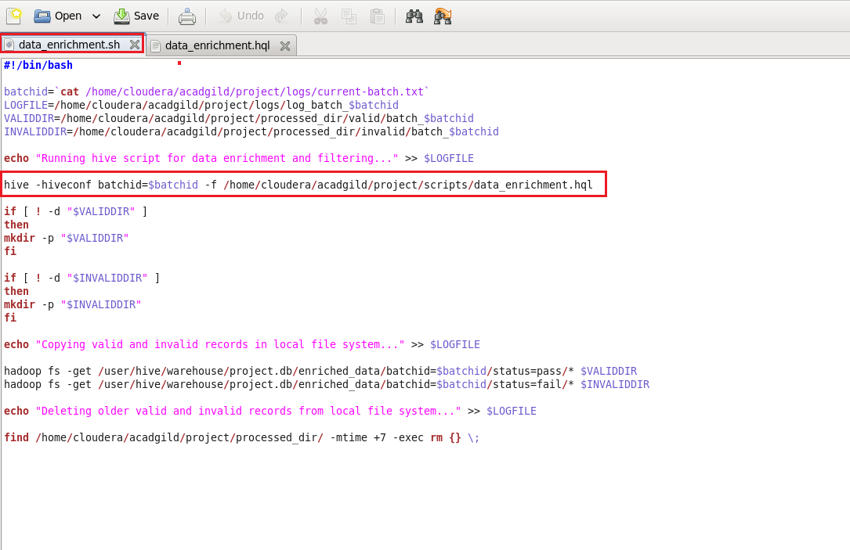

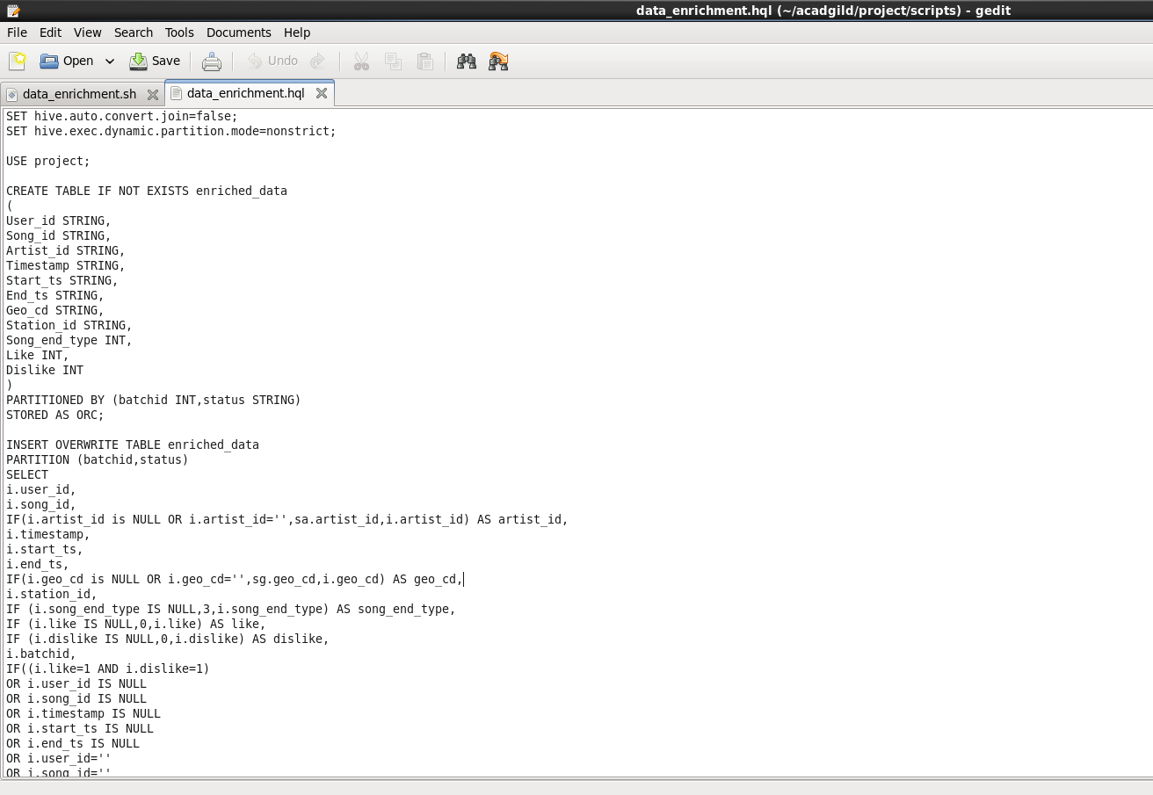

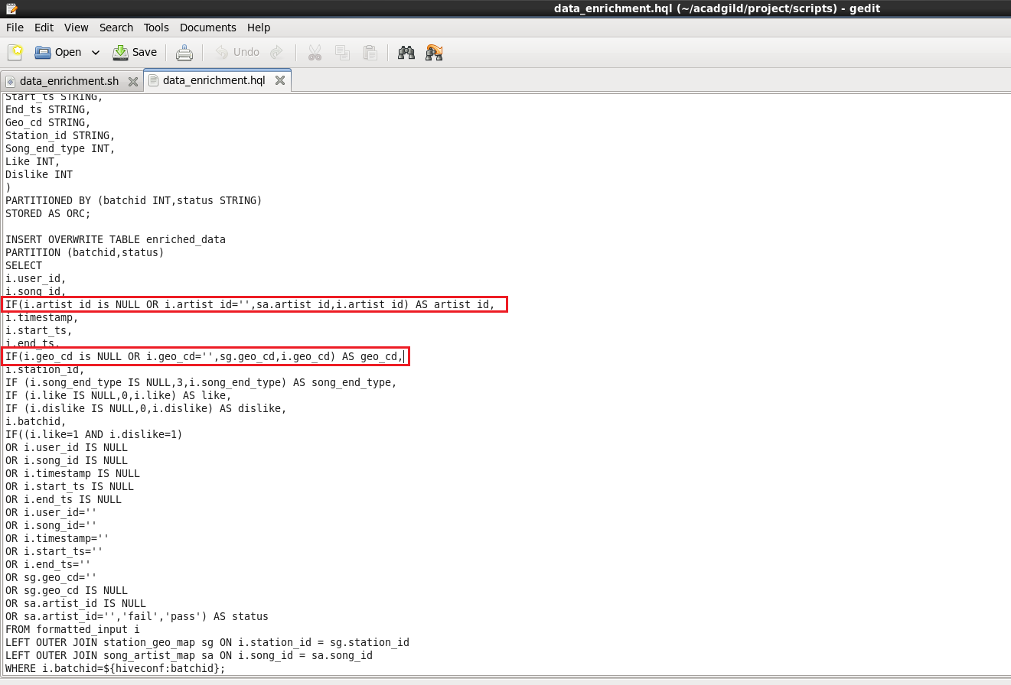

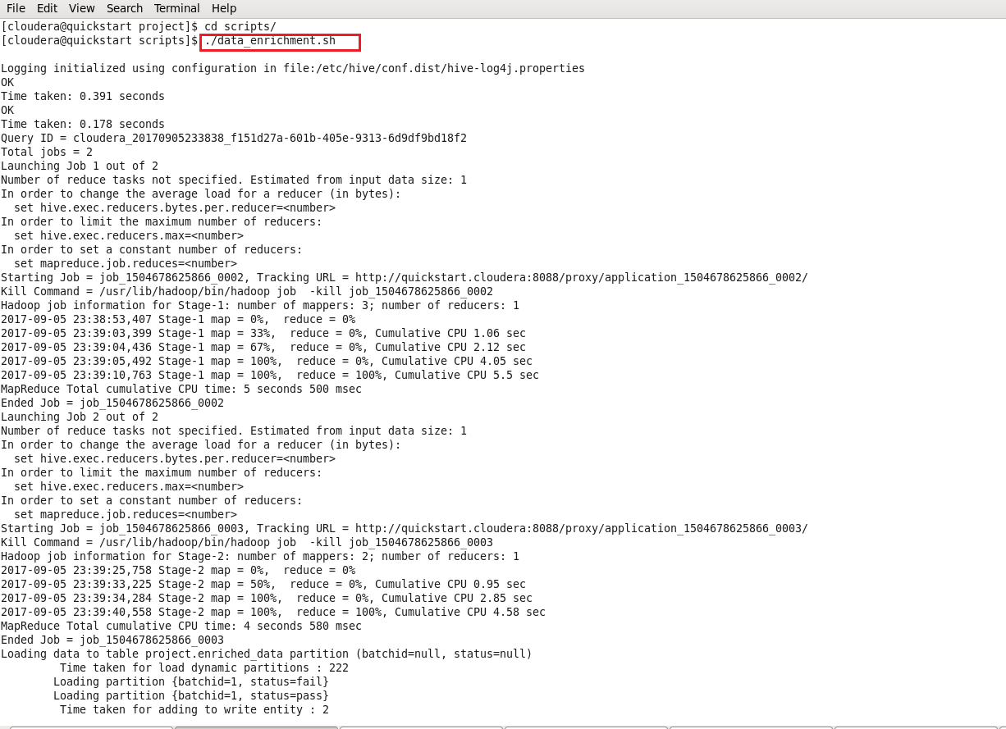

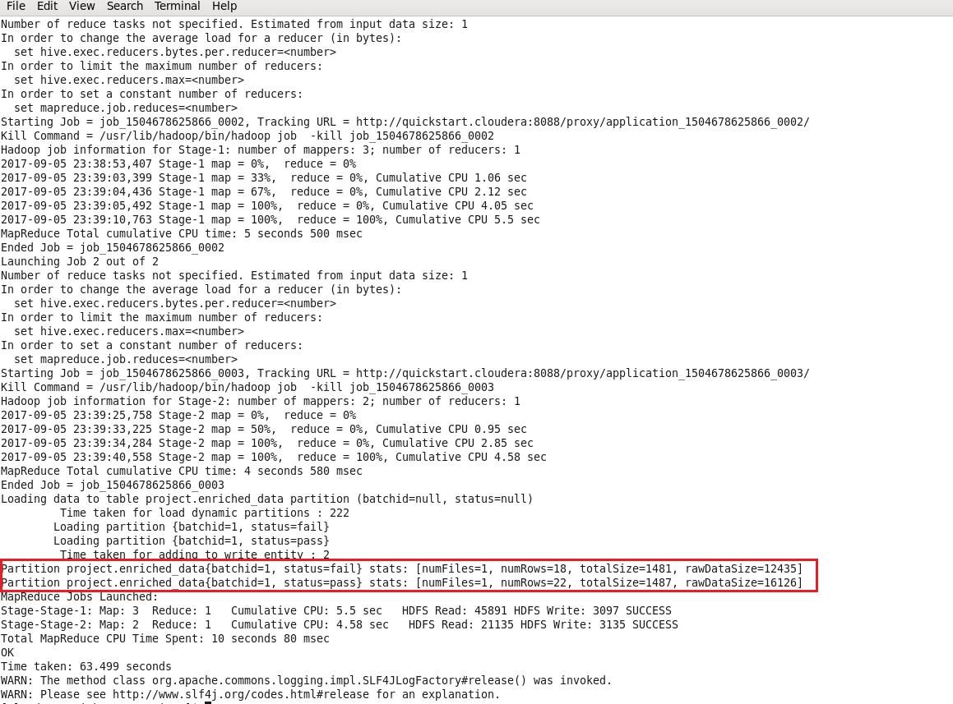

At the end script will automatically divide the records based on status pass & fail and dump the result into processed_dir folder with valid and invalid folders.

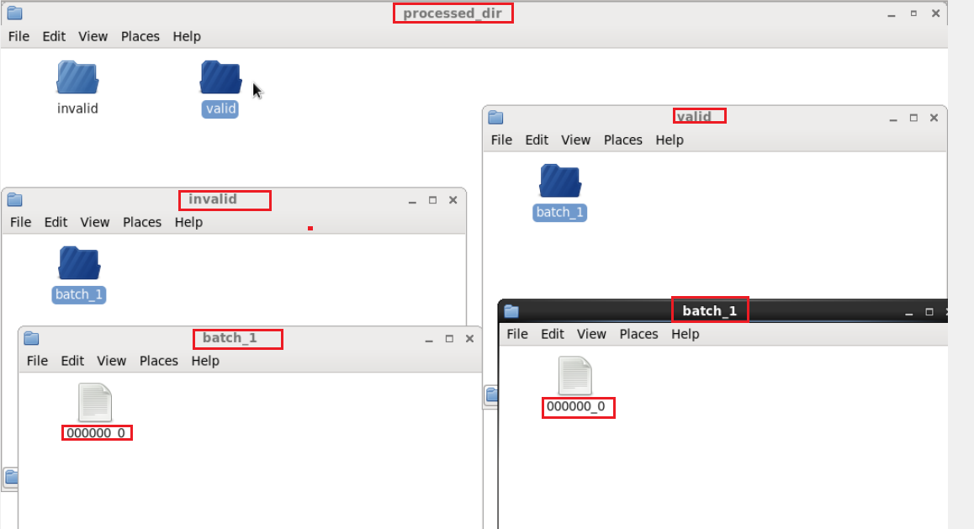

* Now we can check whether the data properly loaded in the hive terminal or not .

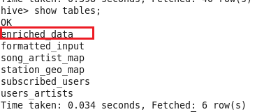

* In the below screenshot we have data for data enrichment table where we filled the null values of artist_id and geo_cd of formatted input with the help of lookup tables

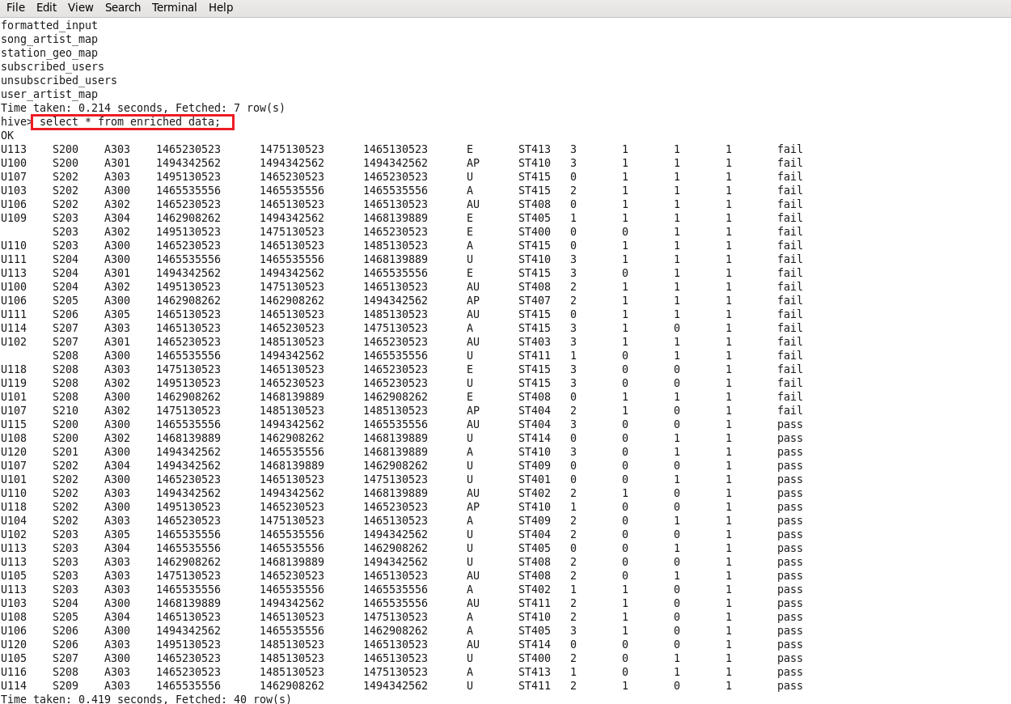

* Enrichment phase is executed successfully by applying all the rules of enrichment.
  1. **Data Analysis using Spark:**
* In this stage we will do analysis on enriched data using Spark SQL and run the program using **Spark-Submit** command.
* Before running the spark-submit command we have to **zip –d command** to remove the bad manifests in created spark project jar file to avoid the invalid Signature exception.
* I used two spark-submits for analysis. 1) Spark_analysis for creating tables for each query/problem statement.

2) Spark_analysis_2 for displaying results for each query in terminal.

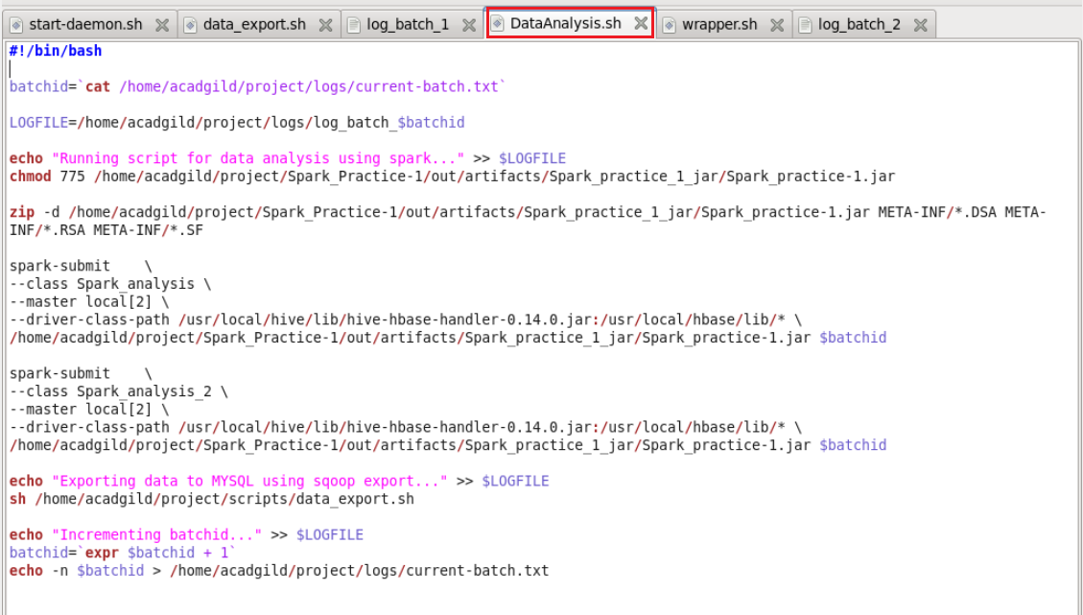

**Spark Source Code:**

I have created one Scala file for creating tables as per query wise.

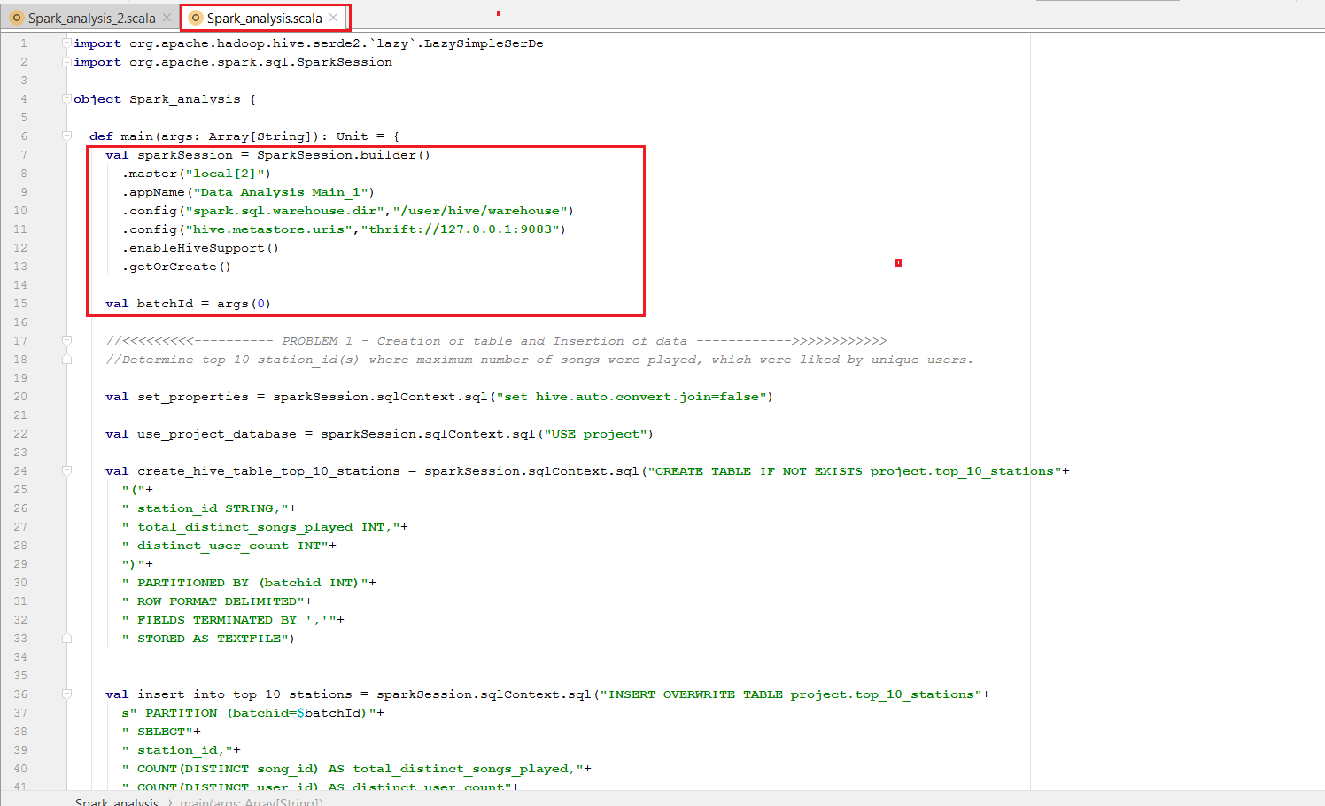

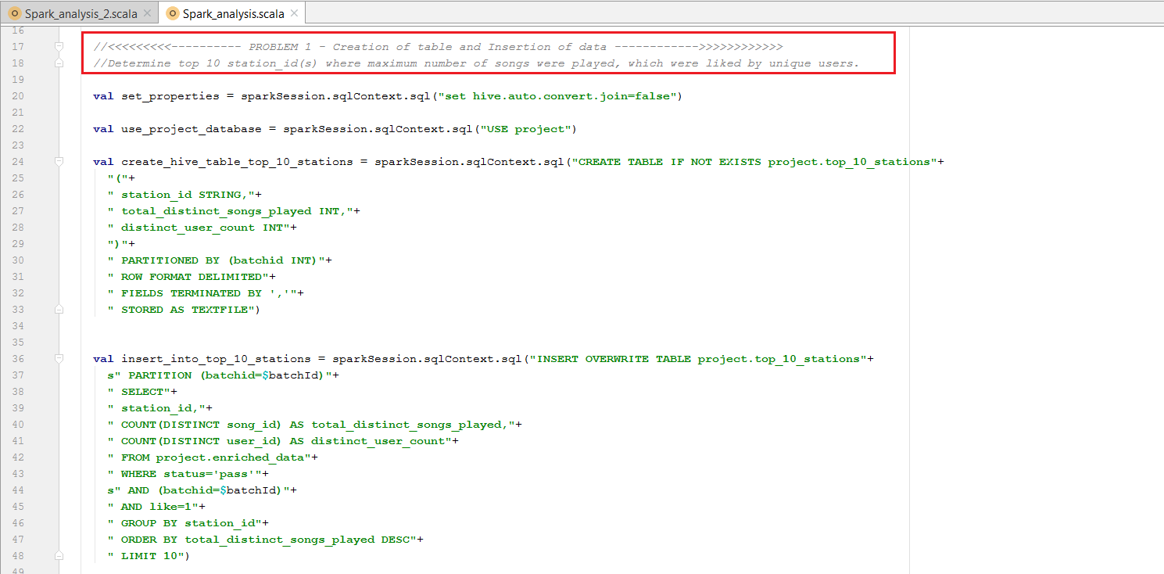

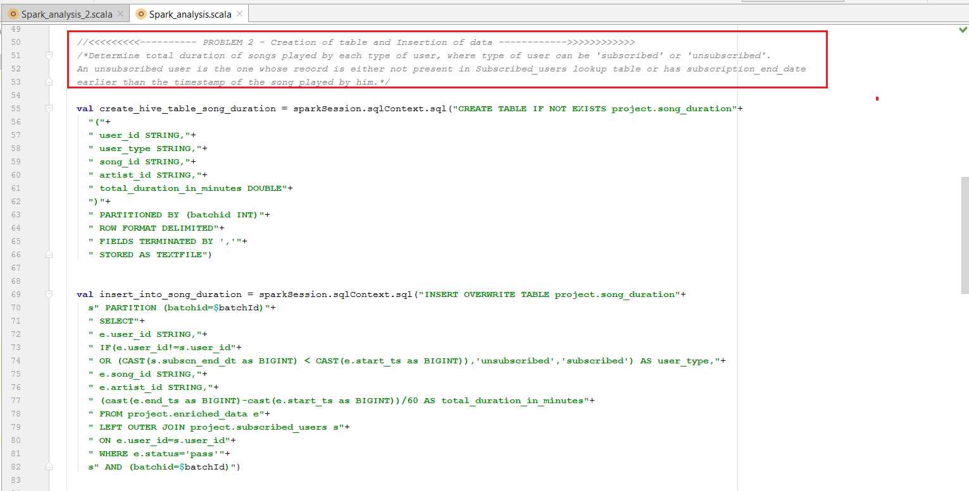

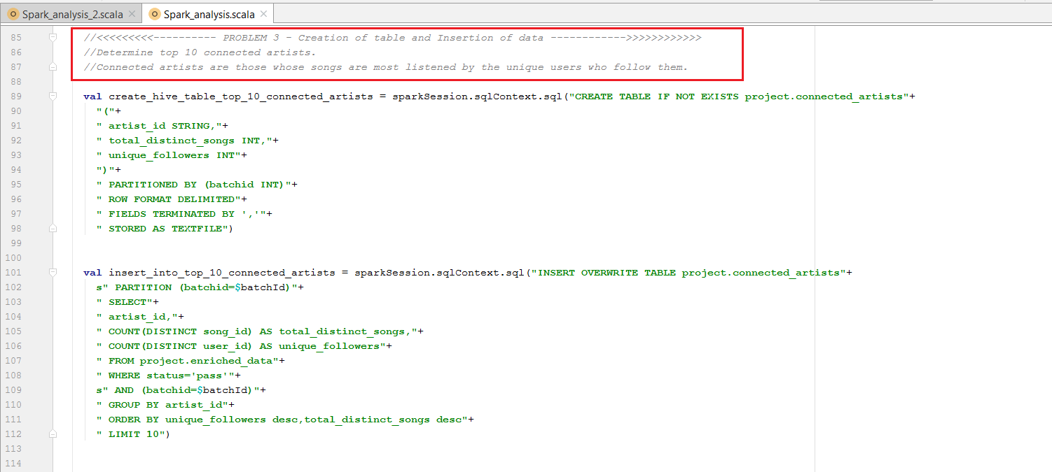

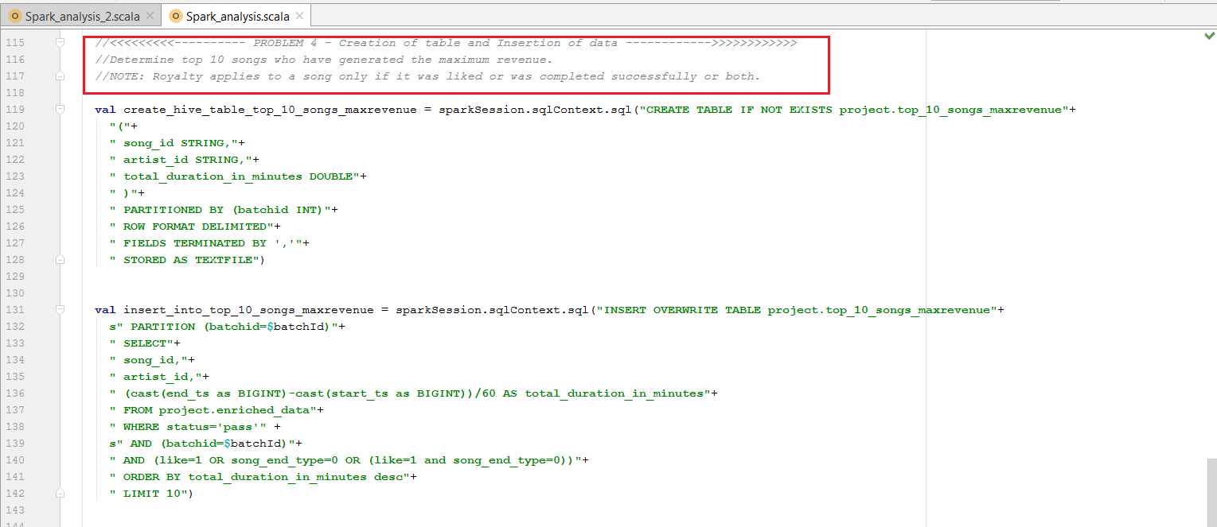

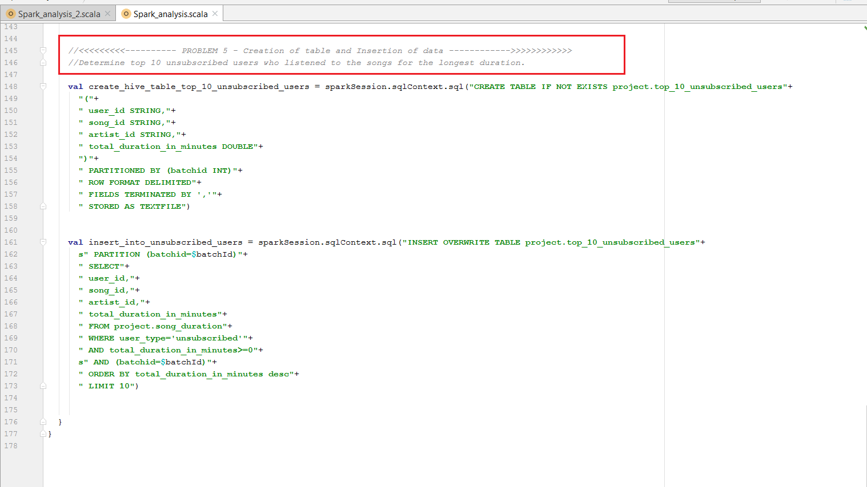

This second Scala file is for displaying results of each query in the terminal.

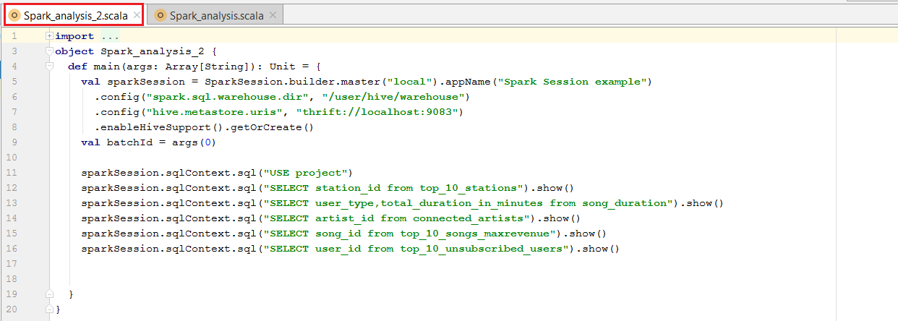

* We will create jar for the above source code using File -> project structure -> Artifacts -> create jar using Build Artifacts command.
* Then we can observe **out** folder getting created with artifacts inside it.
* Now we will export this jar to VM where we will run using spark submit command and get the analysis result.

When we run the Data Analysis First it will submit Spark_analysis file and then it will run the Spark-analysis_2 file which displays the result for each query.

**Spark analysis output:**

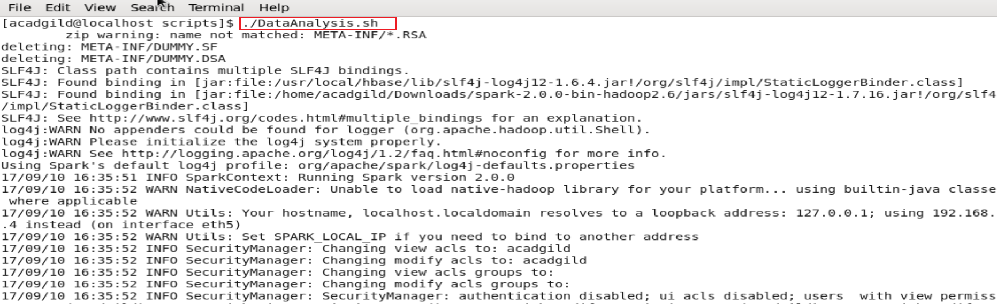

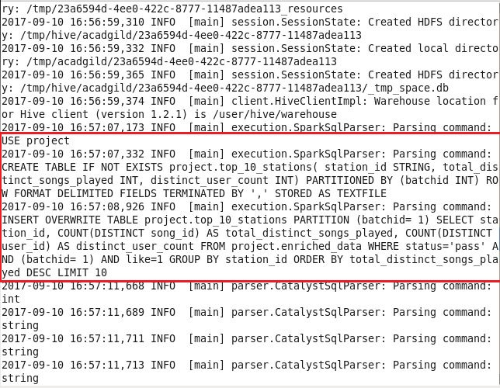

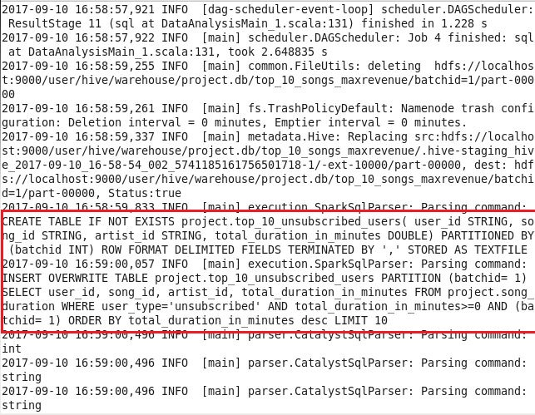’

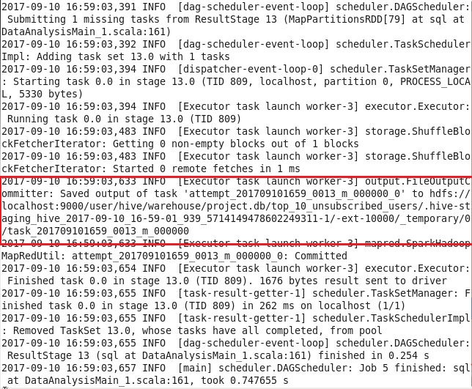

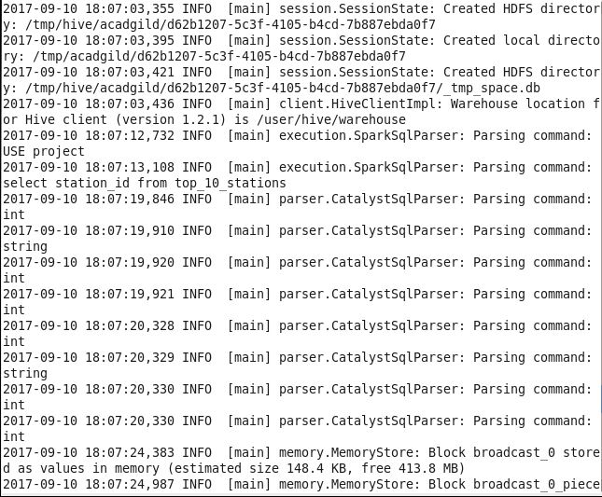

**Spark analysis_2 output:**

Query-1: Determine top 10 station_id(s) where maximum number of songs were played, which were

liked by unique users.

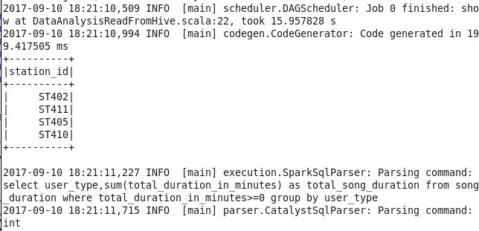

Query-2: Determine total duration of songs played by each type of user, where type of user can be 'subscribed' or 'unsubscribed'. An unsubscribed user is the one whose record is either not present in Subscribed_users lookup table or has subscription_end_date earlier than the timestamp of the song played by him.

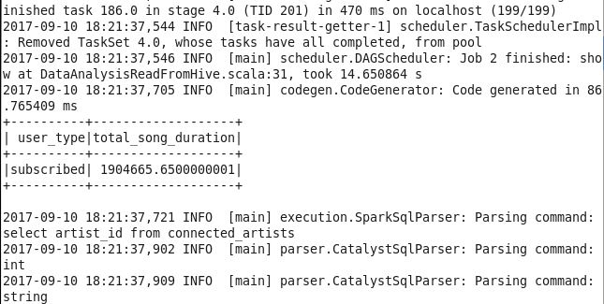

Query-3: Determine top 10 connected artists. Connected artists are those whose songs are most listened by the unique users who follow them

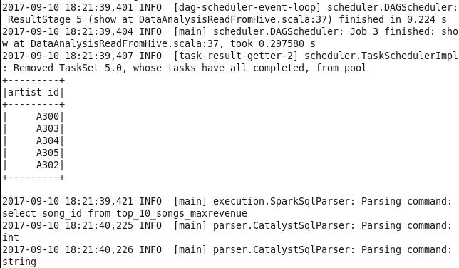

Query-4: Determine top 10 songs who have generated the maximum revenue. Royalty applies to a song only if it was liked or was completed successfully or both

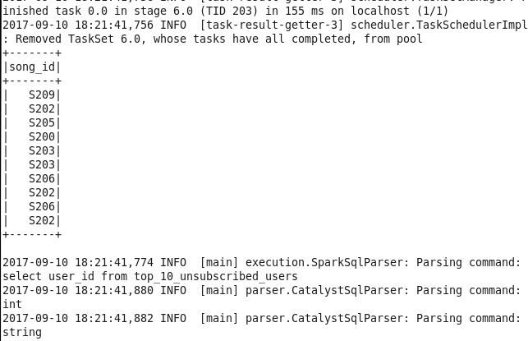

Query-5: Determine top 10 unsubscribed users who listened to the songs for the longest duration.

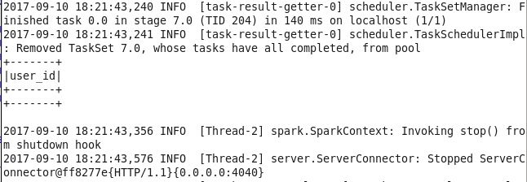

For this query we got no result because there is no unsubscriber whose has got positive total _duration_minutes_in_minutes. All the unsubscribed users got negative total_duration means their end timestamp is less than the start time stamp of the song which is not correct.

Now we can see the output of Spark analysis in hive:

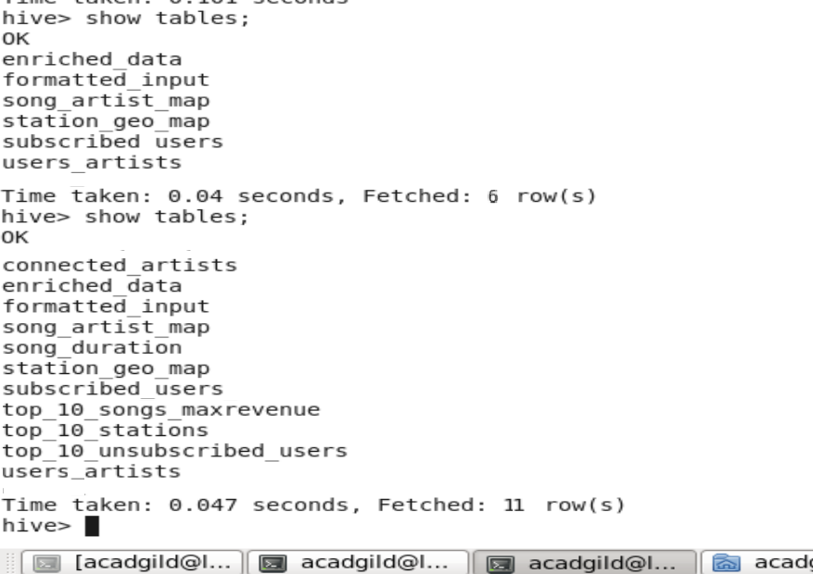

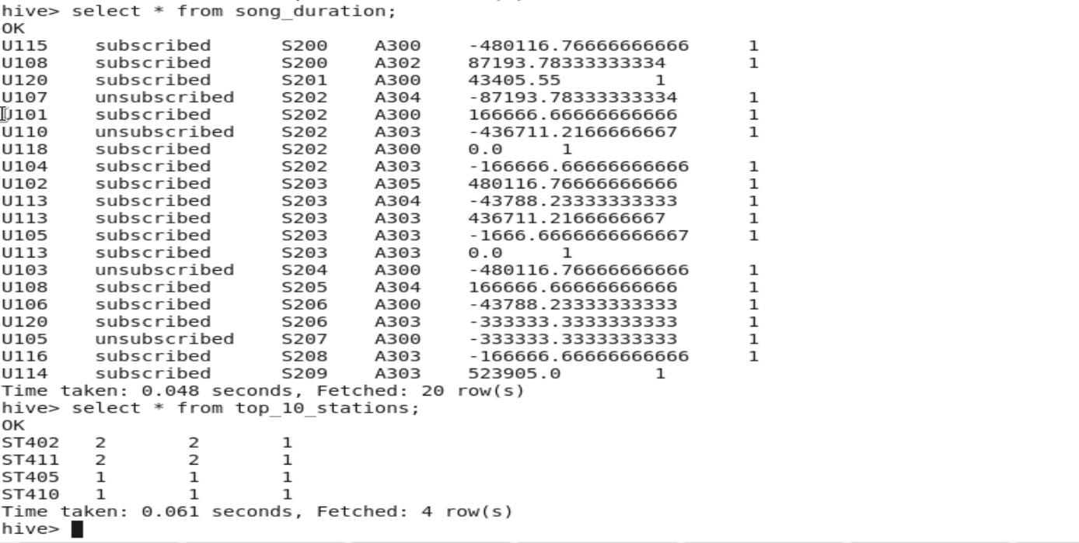

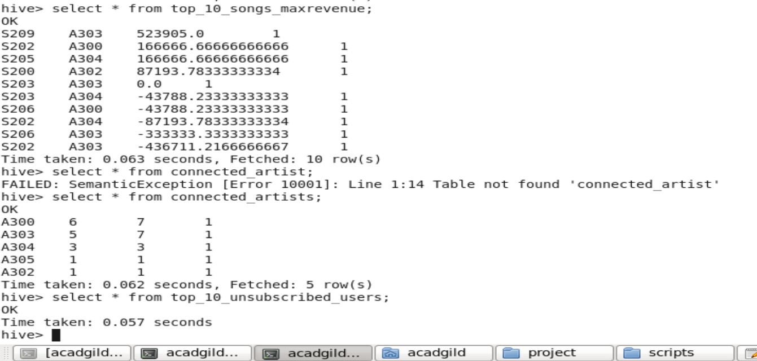

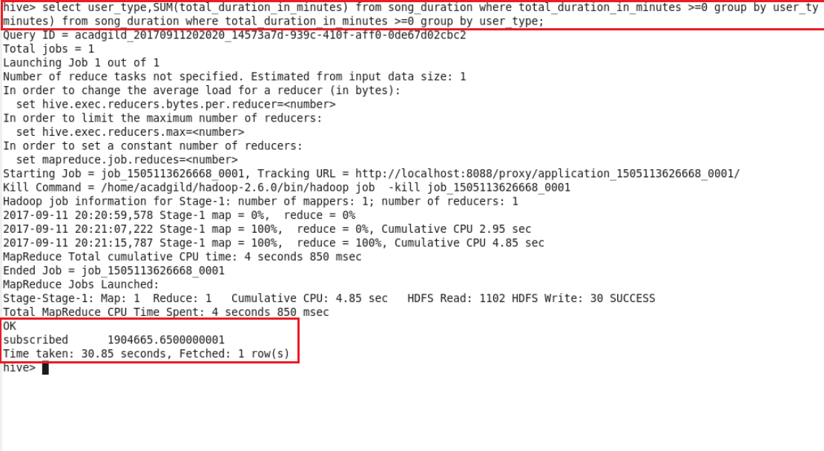

Now we have seen all the spark queries creating the tables for each query. So Data Analysis using Spark is executed successfully.

* 1. Data Export to MYSQL:

In this stage data will be exported from hive warehouse directory to MYSQL database using data_export.sh command mentioned in the DataAnalysis.sh script.

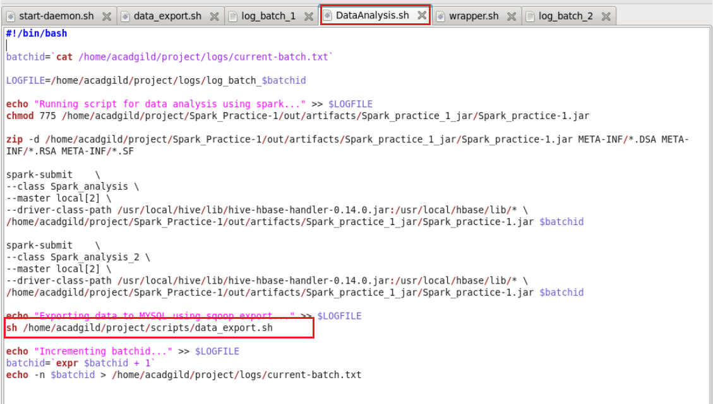

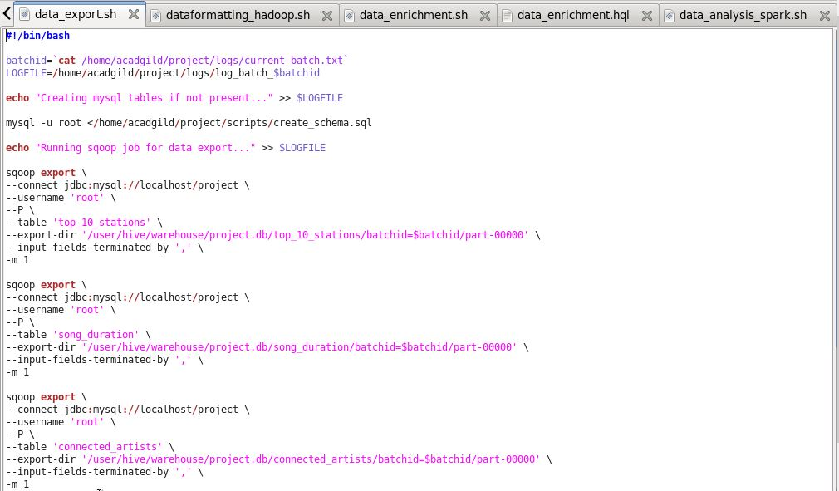

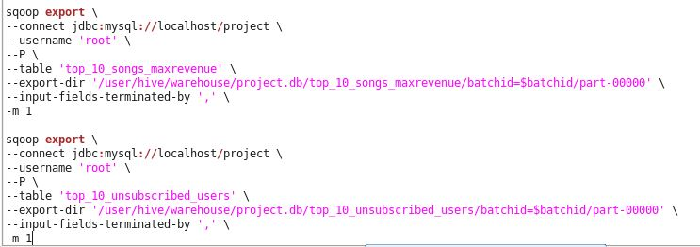

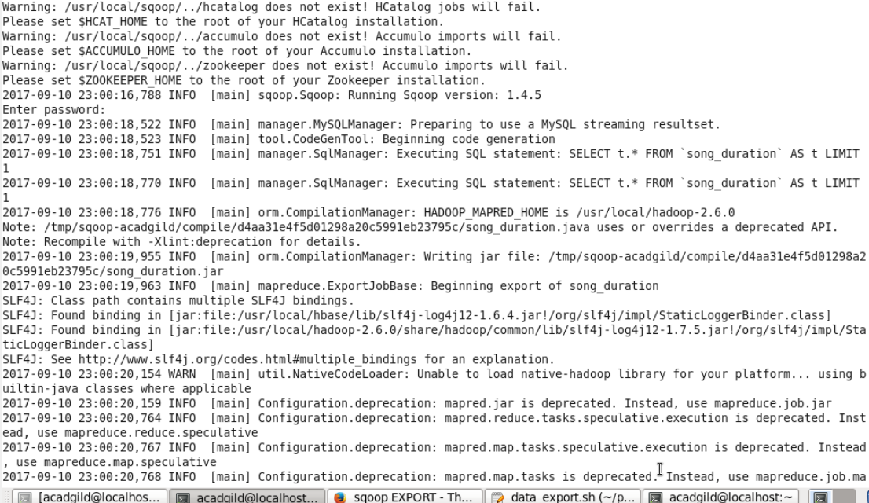

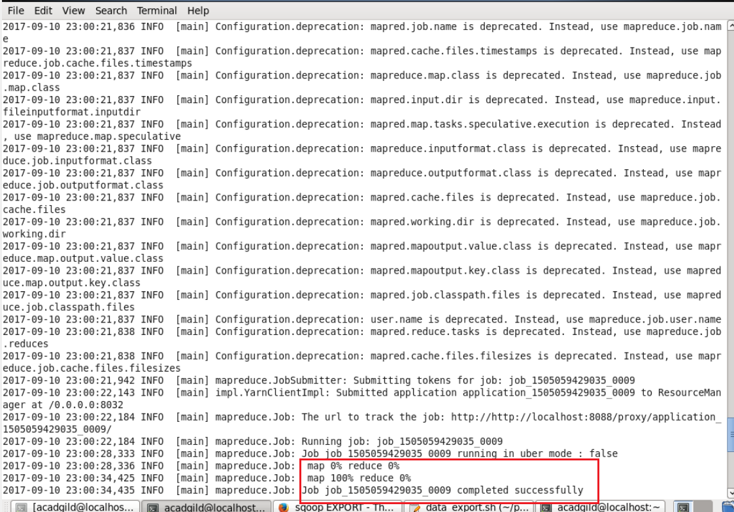

Now we can see the data exported successfully into the MYSQL Database for all the 5 queries.

**MYSQL:**

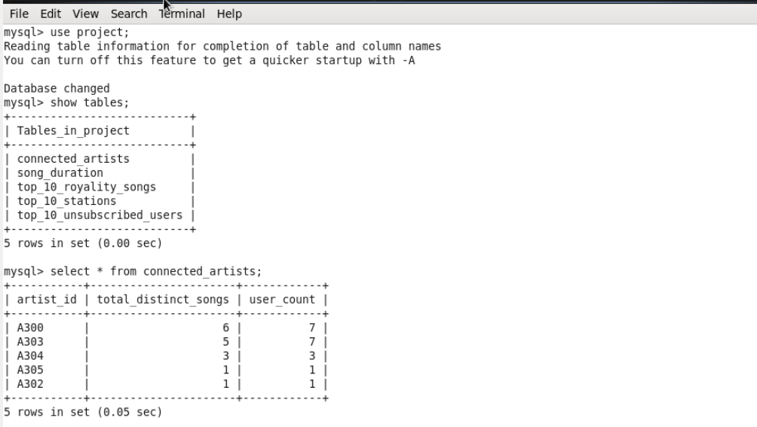

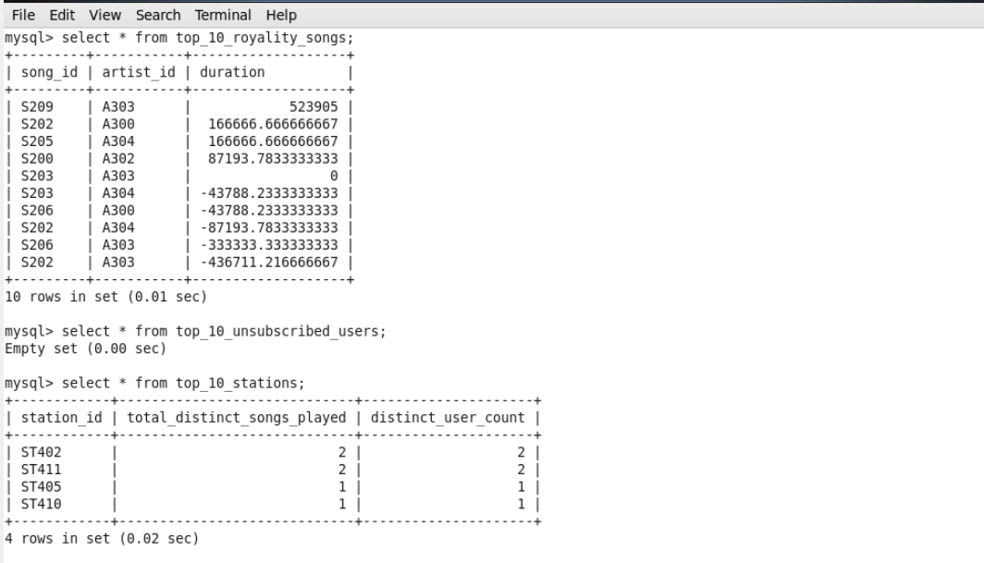

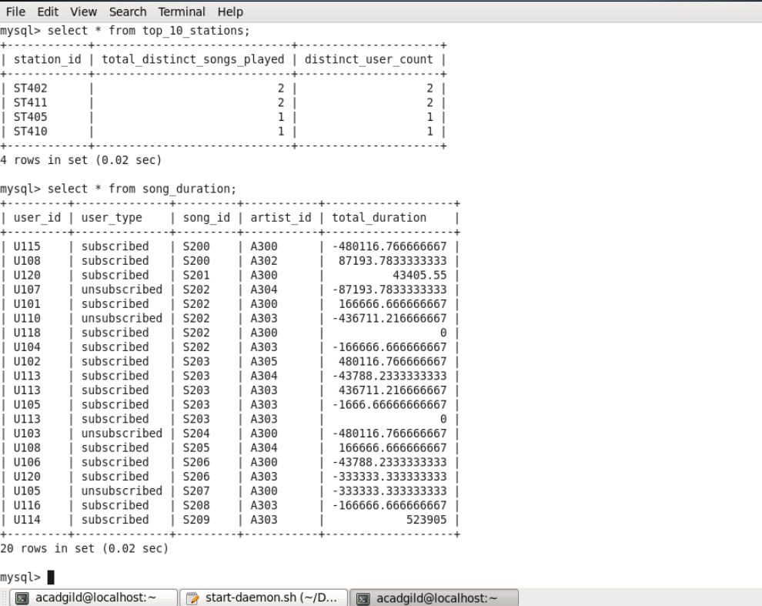

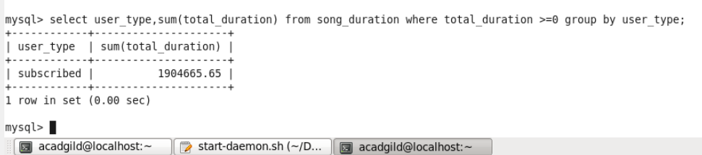

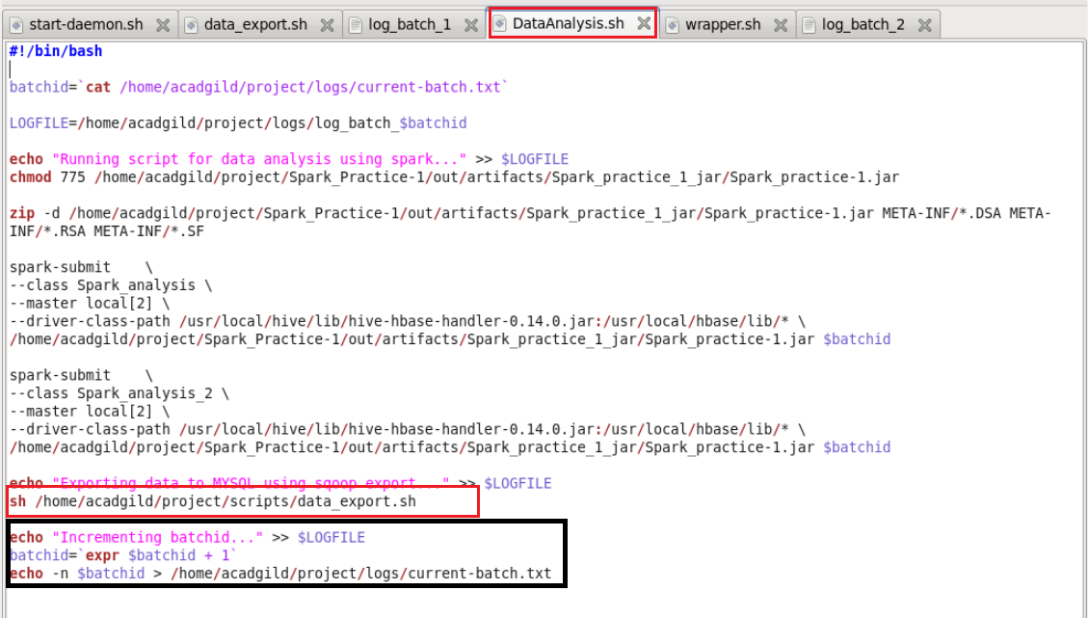

Now after exporting data into MySQL batchid will be incremented to 2 means one batch of data operations is successfully completed and new batch of data will be loaded for the analysis after every 3 hours.



We can check logs to track the behaviour of the operations we have done on the data and overcome failures in the pipeline and we can see the batchid incremented value in current-batch.txt.

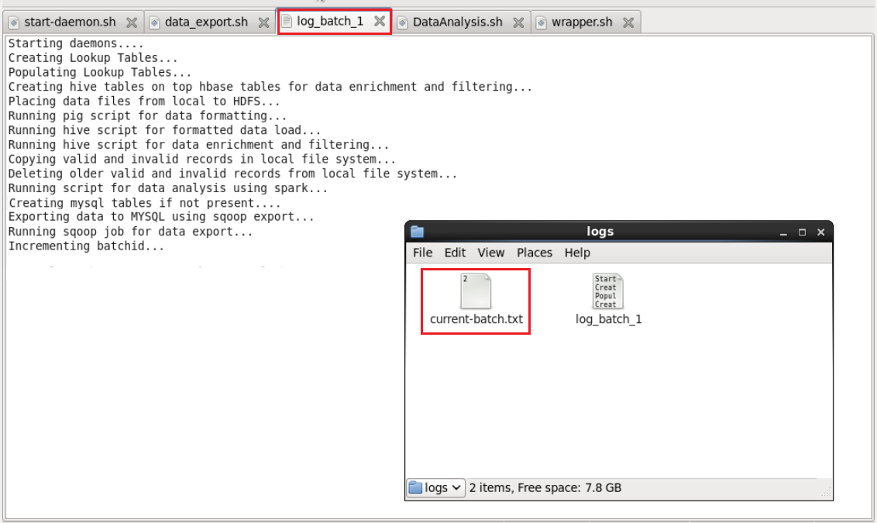

* Wrapping all the scripts inside the single script file and scheduling this file to run at the periodic interval of every 3 hours.

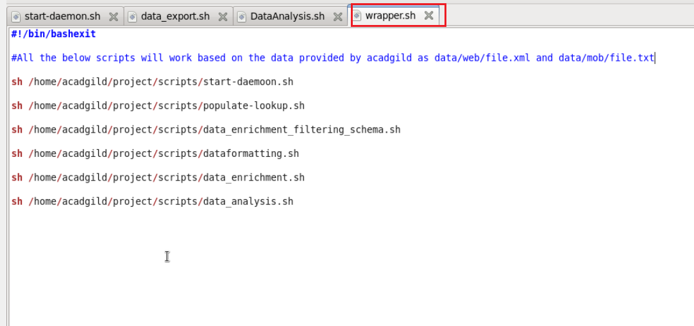

* 1. **Job Scheduling:**
* Creating Crontab to schedule the wrapper.sh script to run for every 3 hour interval.

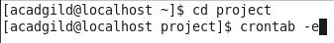



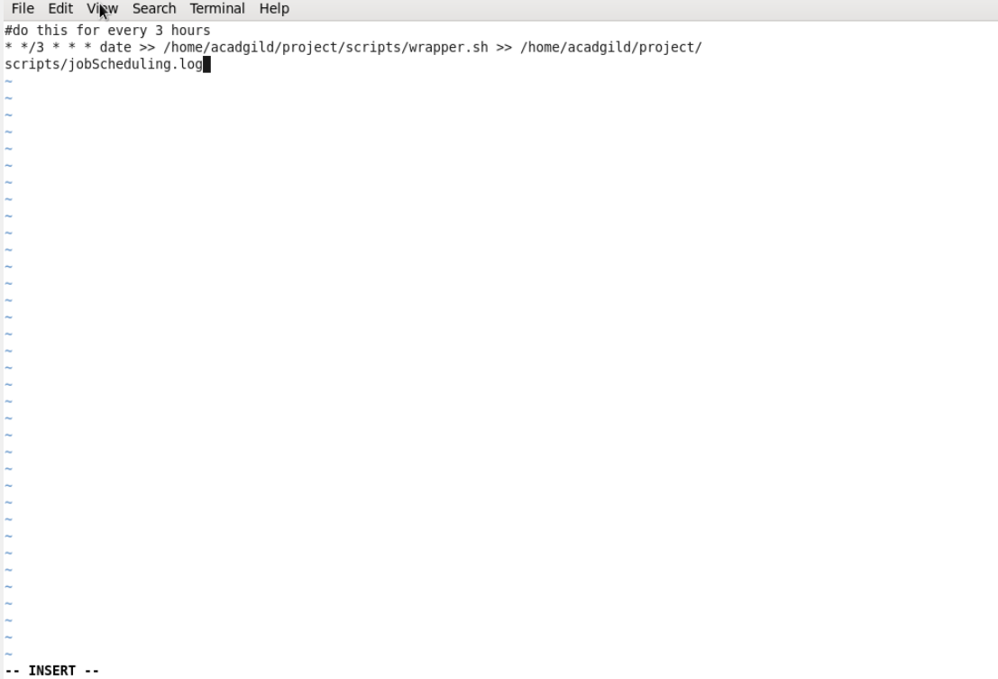

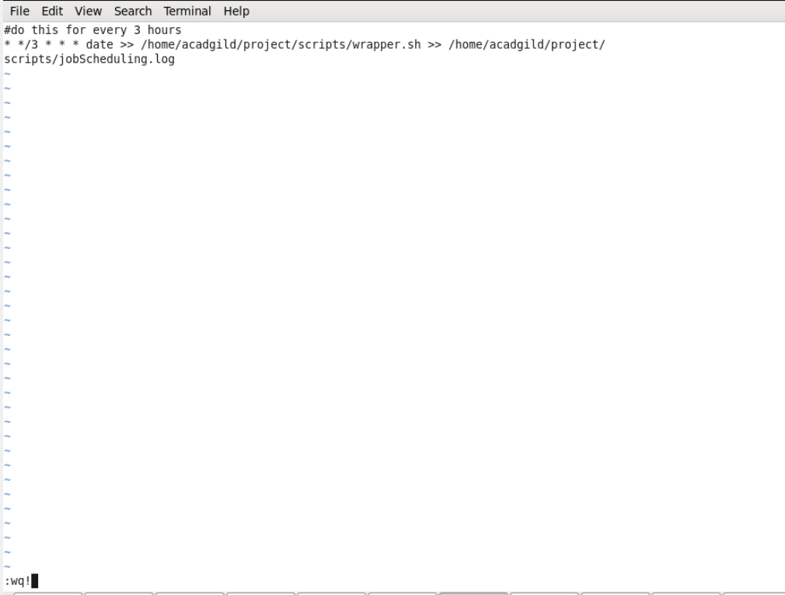

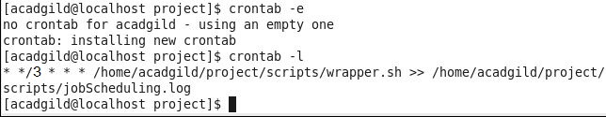

1. **Conclusion:**

So we performed all the data operations as per the sequence mentioned in the wrapper.sh file and obtained results successfully for the one of the leading music company.